Doctors Without Borders
Darlene Hillberry
MVNU

ISBN-3013-B1S9O

Table of Contents
Abstract 3
Historical Background 4
Objectives of The Organization 6
General Operation and Problems faced 7
Innovation with Impact 7
Impact on Business and Trade 9
Recommendations 10
Conclusion 11
Image 1 12
Image 2 12

Abstract
Doctors without borders remain one of the most renowned humanitarian NGOs offering medical service to conflict zones. It has remained significant for now over forty years having over thirty-five thousand personnel. This personnel ranges from professional doctors and nurses to other medical officers as well as engineers and water sanitization officers who are of importance in the mission of the organization. The organization has a huge operation budget that surpasses over a billion dollars and mainly comes from individual donors with a small portion coming from corporate donors. Today, the organization is in operation in over seventy countries across the world.
Keywords: Doctors without borders, NGO, Humanitarian

Historical Background
The organization started in Nigeria during the 1967 to 1970 civil war. During this time, the French were in Nigeria as the Eastern region of that country became independently recognized as Biafra. Those people living in that country faced difficulty immediately after a blockade was kept by the military. Children were attacked by hunger as the adults faced several infections. People started dying miserably in that region due to political conflicts. Several French doctors were in operation in this region trying to help the Biafrans.
The French red cross too was working closely with these doctors with the help of the government. However, the government and the Red cross were doing so for political reasons and were religiously biased on who to help. The volunteers were touched by how people starved to death in the blockading forces (Kugler & Sauer, 2005). The doctors were angered on how the French Red Cross and the government worked in this area. They went public and pronounced the wrongs of the two, criticizing their activities and demanding the formation of a whole new organization. One of these early founders of the Doctors Without Borders was Bernard Kouchner.
The new organization was to specifically focus on the welfares of the people rather than the political and religious affairs of the citizens. Emergency Medical and Surgical Intervention Group were formed in response to this even though another organization called French Medical Relief had been formed by an interested editor journalist to respond to the 1970 Bhola cyclone. In the year 1971, the Emergency Medical and Surgical Intervention Group teamed up with French Medical Relief to form the Médecins Sans Frontières (MFS) which when interpreted in English meant Doctors without borders.
After its formation, in 1972, the team had its first task after an earthquake had hit the Nicaraguan capital called Managua. Two years later, in Honduras, Hurricane Fifi caused mass deaths and the organization responded first to set up a station in which medical services were offered to the injured (Kugler & Sauer, 2005). The organization too did its first-ever Refugee camp in Thailand after millions of Vietnamese ran for their lives immediately the South had fallen to the North. In 1989 the Doctors without Borders set up a reconstruction program after the war in Vietnam had settled helping the country in rebuilding its health sector.
These initial missions of the NGO did not sound very hostile as they had never operated under an environment of real war. However, in 1976, the organization faced a terrible time as they camped in Lebanon to aid those who were victims of war in the ongoing Lebanese civil war. This camping mission which was also very long as it went down for Nine years was the first hostile condition that the volunteers had ever been exposed to (Fox, 2014). During this time, they offered services to anyone despite religion (considering the country had both Muslim and Christian fighters) and when the situation got out of control in 1984, they withdrew their help.
For thirty years, the organization had had internal feuds as their former leader was in support of issues such as; medics speaking of their experience and the use of a firearm for welfare purposes as well as the intervening programs. However, the organization together with Claude Malhuret who was pronounced president of the organization in 1977 did not support these ideas in the quest of escaping critics (Fox, 2014). The newly elected president in hand with his Successor, Rony Brauman worked tirelessly to improve the organization by providing it with financial stability. The most significant of all they ever did was the introduction of the Fundraising-By-Mail initiative which ensured the easier collection of donations from willing volunteers.

Objectives of The Organization
The organization was formed with two primary purposes which are Provision of free service to tragedies-stricken areas and abolishment of bias nature in service deliveries. The first is the main objective of the NGO since they travel from place to place where disaster and calamities hit to offer a hand of help without asking for anything in return (MSF, 2018). Just as their first part of the organization's mission statement outlines “provide impartial medical relief to the victims of war, disease, and natural or man-made disaster” the Doctors without Borders group are determined to help in that particular way.
The second objective which was probably the main reason the organization was formed was to build up an aid organization that would deliver its services without considering people’s differences. The second part of their mission statement reads “without regard to race, religion, or political affiliation.” Following what they had witnessed back in Nigeria by the neutrality of the Red cross, they hated when such concerns blocked delivery of welfare services (MSF, 2018). They hold it to their hearts that human beings seeking medical or welfare assistance should be helped without consideration of the fact that they are of a different tribe, race, religion, ethnicity, or political ideals.
The group works with professionals and their actions are hugely regulated by the Medical ethics put in place. They are determined in the delivery of reliable and trusted medical assistance to war or calamity victims. The other admirable aspect of the organization is that it is non-profitable and hence there are no interests in finances as there are on the welfares of people across the globe. Currently, about 67000 peoples have devoted their lives in the service of the organization to help it in the attainment of its objectives and accomplishment of the mission.

General Operation and Problems faced
Doctors without borders operate in a structured way to ensure that they accomplish their mission without interrupting the social and political setting of the aid receivers. Before setting up any mission, a field team is sent to spy on special things such as security levels and the kind of assistance required. Usually, this initial stage is referred to as the Exploratory Mission. After that, the necessary teams are sent in to offer the aid required for the time articulated (Fox, 2014). Usually, statistical surveys are done in every mission to ensure that afterward, they will be able to offer accountable reports to stakeholders and the media.
Currently, the organization has served thousands of missions successfully. However, this has not been easy for them as their workers face a lot of issues while in the field. The first being injuries and deaths that may result from shootings in war areas. This has happened over time as some doctors go to missions and either come back disabled for a lifetime or never come back at all. The other problem that they face is diseases in the field which may be a result of being unable to cope with new regional weather conditions.

Innovation with Impact
Currently, human beings are living in an era that is characterized by prodigious scientific advancement. Technology is at its peak and most sectors of the economy have centered a lot of effort into assimilating new means of work. However, the medical sector has continuously faced problems resulting from people being unable to access essential medical care. The doctors without borders organization have brought about a whole new way of ensuring technology and medical care are intertwined for the benefit of the patient (BBC, 2018). The organization is trying to transform the style in which high-quality medical services are delivered to people in a bad situation. The doctors without the border team understand the underlying issues and work tirelessly to deliver emergency services and transform the field of medical services in the various number of ways that they implement in their functioning.
First is the use of drones in their services to access the remote areas in which victims of war may be lying helplessly. The goal being to cover a larger population of victims in the shortest time possible, the drones work in handy to ensure access of areas that maps may not be covered due to issues of being absent or being outdated. This kind of technology was a relieving one as other people and organizations in the same industry have adopted it to enable them to be able to map remote areas by simply flying a drone and taking a picture.
The other form of the idea that the Doctors without Borders implemented that became a tool for hire to other related businesses was the mobile surgery idea. Currently, an appealing creation of a project called MUST which is a mnemonic expression of Mobile Unit Surgical Trailers led to great success in the accomplishment of 100 operating intercessions. After its first application in Iraq, back in 2017, it registered a great success (BBC, 2018). It has posed a challenge to most companies and NGOs with such intentions as saving war victims. It is a low-cost way and very flexible for doctors to operate people in temperature-controlled hygiene tents.
The 48 hours hospital is another impact of the organization on the extended industry. Due to war and other calamities, NGOs such as Doctors without Borders face a lot of difficulties that relate to how to set up a fully functioning hospital. However, from 2005 the company brought to table a whole new idea that shock most people and fostered more advancement. That was the putting up of a well-packed inflated hospital that can be expanded or can be demolished and be moved elsewhere easily. They were first used in Pakistan and Congo where there was a need to create space in the medical centers.

Impact on Business and Trade
The organization statistically has had a great impact in the medical world as compared to its equals. The NGO is currently running twelve hospitals and health centers that are fully equipped. Between the years of 2015 and, 2019 more than ninety thousand surgical interventions were carried out by the organization in its quest to help patients of various complications. Over two hundred thousand patients from war injuries have also been treated and are well now through the assistance of Doctors without Borders (CI, 2017). Over seventy thousand babies have been born in the hands of this organization and during the outbreak of the deadly disease Ebola in Africa, the team admitted over three thousand patients.
According to Ci’s, the organization registered the highest impact per dollar in the financial year of 2016-2017. vaccinations 44%, medical surgeries 28%, and medical treatments 24%. In 2016, MSF-I vaccinated more than 4 million people responding to disease outbreaks, reducing disease levels. In 2016, MSF-I performed 92,000 surgeries and supported/assisted in 225,000 surgeries, and assisted in 180,000 births reducing child and maternal mortality (CI, 2017). The third driver, medical treatments, reduces death rates in people who are already ill. MSF-I treated 2.8 million people with transferable diseases and intervened with 290,000 children facing severe acute underfeeding.
In totality, the impact that the organization has brought to the industry is great and has modeled inordinate challenges to other officialdoms. With the amount received from donors, the NGO has desirably facilitated its tasks ensuring none of these is done in a meritocratic way.

Recommendations
The organization currently needs to work on a few things to ensure its future is much brighter than today. The first issue that ought to be addressed is the security of the medics and other officers who sacrifice a lot to go to the field and save lives. In the field, it is evident that these individuals face untold problems that are either physical or psychological. Some are shot dead; some sustain lifetime injuries from the war zones and others end up losing friends or similarly witnessing incidences that are troubling to the mind in a large way.
The organization should ensure better security for the life-savers to and back to their homes and great compensation to the beneficiaries in case of death. Similarly, they should be able to partner with psychiatrists who may help those facing psychological trauma from previous missions. On the other side, the organization should closely work with the UN and other governments to ensure that as they carry out their work, they can access as many people as possible with the help of the government. Either by funding or mere policy formulations that will better their functioning, they should partner with the government for the success of the mission.
Some policies put in place may hinder their operations and that would be in a great way tragic. The organization has been able to work closely with individuals of interest as well as corporates but at the same time, it would be good if the organization call out to partner with the different government who may be willing to either fund them or offer any other assistance in the verge of assisting their citizens. That is why it is of great importance that the organization tries and team up with administrators from various countries.

Conclusion
The Doctor Without Borders or as known in French Médecins Sans Frontières (MFS) remains to be one of the most identified and respected medical emergency delivery units in areas where war and calamities have befallen. Since its onset in Nigeria back in the civil war; it has recorded advancements in its technology and impact in the entire globe. The hand of the organization has reached out to the riskiest of all places, endangering the lives of medics in the fight to help a person who is a victim of war to get medical attention.
Their proficiency in their job is admirable and has been acknowledging in the form of various awards including the Nobel peace prize. Today, the organization has stood out in its abilities and capabilities to work in the worst areas and still achieve its missions as stipulated in its mission statement. Finally, even though the NGO is doing well, it stands a chance to improve itself by significantly focusing on better partnerships and donation collection means.

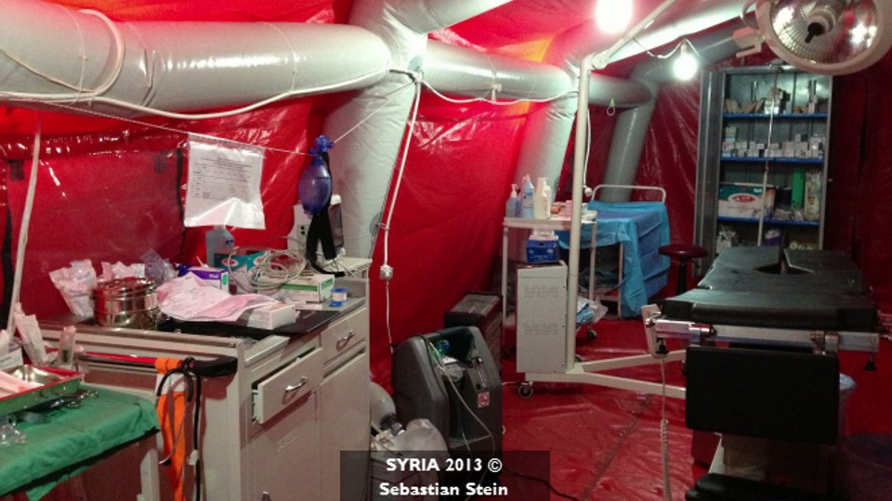
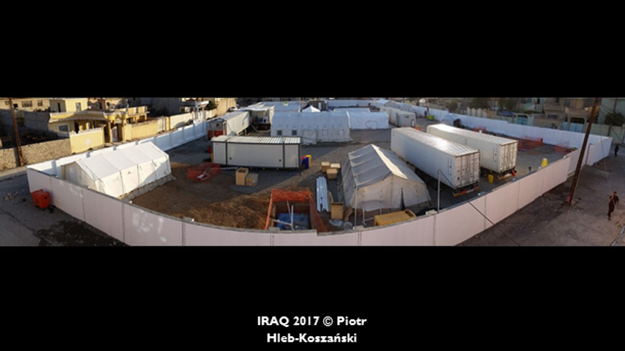
Image 1
Inflated Hospital
MUST mobile health center

Image 2

References
BBC. (2018). Innovations with Impact - Innovating Health Care to Reach Patients Around the World. BBC Story works. http://www.bbc.com/storyworks/innovations-with-impact/innovating-health-care
CI. (2017). Doctors Without Borders. Www.Charityintelligence.Ca. https://www.charityintelligence.ca/charity-details/81-doctors-without-borders
Fox, R. C. (2014). Doctors Without Borders: Humanitarian Quests, Impossible Dreams of Médecins Sans Frontières. In Google Books. JHU Press. https://books.google.com/books?hl=en&lr=&id=JcphAwAAQBAJ&oi=fnd&pg=PP1&dq=doctors+without+borders&ots=SipUqIJeRE&sig=DwiVT2TKPRI0Gf5RfIV1ajyhY80
Kugler, A. D., & Sauer, R. M. (2005). Doctors without Borders? Relicensing Requirements and Negative Selection in the Market for Physicians. Journal of Labor Economics, 23(3), 437–465. https://doi.org/10.1086/430283
MSF. (2018). Médecins Sans Frontières (MSF) International. Médecins Sans Frontières (MSF) International. https://www.msf.org/
‌

